INSTITUTION’S INNOVATION COUNCIL
&
ENTREPRENEURSHIP DEVELOPMENT CELL 2022-2024
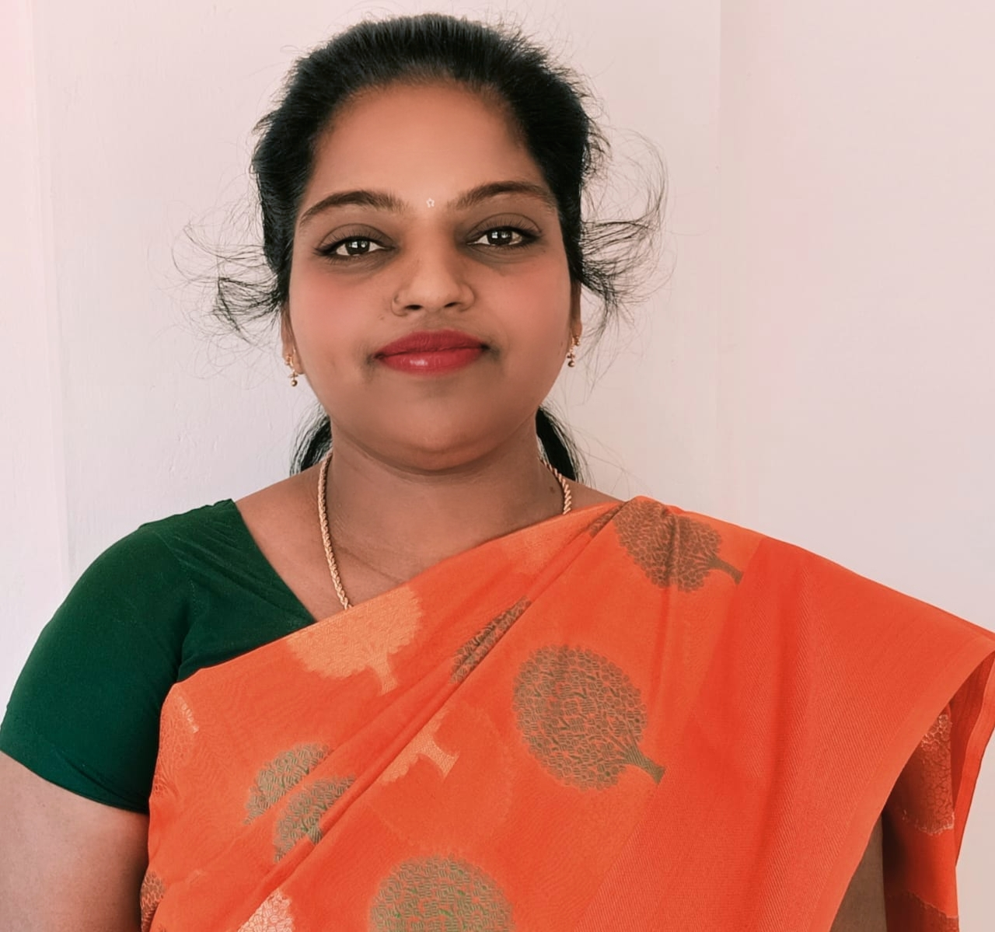

Name of the Head: Dr.JAYASELVI S
Designation: EDC & IIC PRESIDENT

IIC Report 2022-2024

A. About IIC Institute

1. JAS IIC ESTABLISHMENT

Entrepreneurship Development Cell & Institutions’ Innovation Cell was inaugurated on 23.11.2022 at Seminar Hall, Jeppiaar College of Arts and Science.

2. ABOUT JAS IIC
Inspiration is needed for all entrepreneurs to start or grow their businesses. Being an entrepreneur usually means taking a lot of risks, and sometimes he/she must leave a great job to pursue what they love or invest a lot of money into their ideas. The entrepreneur knew that at the end of the day, no matter how scary it may be to take that leap, following his/her heart is always the best course of action, and that is how they became so successful. Entrepreneurship is gradually recognised as a significant driver of the economic growth of a country. The JAS Entrepreneurship Development Cell and JAS Institution’s Innovation Cell were established on 23rd November 2022. Ever since its commencement, the cell has been on its flagship programme of uninterrupted innovative thinking to enhance the country’s economy. At the same time, e-cell also concentrates on the countryside to develop the potential of the youth and revamp their outdated mindset.

3. VISION
Our vision is to transform society by generating creative and successful entrepreneurs fascinated with leadership and managerial qualities using innovative and virtuous business practices.

4. MISSION
To provide the opportunities and support the stimulations of budding entrepreneurs, enlighten the spirit, and implement innovative ideation from start-up to establishment and scaling up with uprightness and sustainability through perpetual supervision and direction through various beneficial programmes and schemes.

5. OBJECTIVES
- To equip and empower the students with substantial skills, competencies, and the spirit of entrepreneurship
- To instruct and encourage the students to turn out to be job creators rather than job seekers.
- To promote innovation, incubation, and entrepreneurial skills through various activities

B.Brief mention of key functionaries at the IIC Institute

S.No | Name | Designation
1. | Dr.Jayaselvi S | IIC President & Convenor
2. | Dr. Monika G | IPR Activity Coordinator
3. | Mrs. Rajeswari K | K NISP Coordinator
4. | Mrs. Parvathavardhini A | Social Media Coordinator
5. | Mrs. Abirami M | Innovation Activity Coordinator
6. | Mr.Johnson A | A Start-up Activity Coordinator
7. | Mr.Rajesh Kannan P | Internship Activity Coordinator
8. | Mrs.Sanshiya A | Internship Activity Coordinator

- Portfolio/graphical/Tabular representation of Resource strength (human capital and Physical capital) of the IIC institution
- Total No. of IIC Members -168
- Total No. of IAs -33
- Total No. of faculty Mentors -11
- Pre-Incubation Units, If any -yes
- Incubation Units, If any - no
- IP Facilitation Unit, If any -no

- Highlight Facilities, Infrastructure of Pre-Incubation & Incubation kind and Student bodies/clubs engaged in promotion of Innovation and Entrepreneurship in the campus.

- Highlight Achievements:
- Number and Different types of I&E and IPR activities Conducted -66
- No. of student’s & faculty ideas generated -35
- No. of student’s & faculty Innovation/prototypes developed -1
- No. of Student &Faculty Start-ups/Ventures established. - 1
- Amount spent on promotion and awareness generation on Innovation Entrepreneurship in the campus Rs.210000
- Amount grant or fund supported to student & Faculty lead Innovations, start-ups and IPR - Nil
- No. of Technology Transfer and Commercialisation happened -Nil

- Participation of IIC-institute in various programs of Central and Stage Govt. Highlighting specially for the schemes or programs
- ARIIA – participation
- NISP Adoption status – Yes (21 Trained Faculty, Policy Formulated and Policy Implemented.
- Smart India Hackathon – 2 times conducted.

1. FUNDING
- Dr.S.Jayaselvi received the funding Rs.10000 from IEDP EDII-TN for conducting Entrepreneurship Development Program which was held on 20.02.2023.
- Dr.S.Jayaselvi received the funding Rs.5000 from IEDP EDII-TN for conducting Social Entrepreneurship Awareness Program which was held on 09.05.2023.

2. Honour from EDII-TN
- Dr.S.Jayaselvi was selected from EDII-TN IEDP UNOM Hub to evaluate the School Innovation Development Projects (SIDP) and attended Boot camp on 31.01.2023.

3. FDP
- Dr.S.Jayaselvi participated in the Three-Day “Faculty Development Programme” organised by the Innovation & Entrepreneurship Development Programme (IEDP), EDII-TN, University of Madras Hub from 27.02.2023 to 01.03.2023 at University of Madras, Chennai.

4. EXPERT LECTURE DELIVERED
- Dr.S.Jayaselvi, has delivered a speech on “Ethics and Social Responsibilities for Entrepreneurs” on 18.04.2023 through virtual mode, organised by PSG College of Arts & Science, Coimbatore.

- Dr.S.Jayaselvi, has delivered a speech on “Entrepreneurship Skill, Attitude and Behaviour Development” at Kumararani Meena Muthaiah College, Adayar, Chennai on 14.03.2023.

- Dr.S.Jayaselvi, has delivered a speech on “Entrepreneurship Skill, Attitude and Behaviour Development” on 07.01.2023 through virtual mode, organised by St. Mother Theresa Engineering College, Thoothukudi District.

- Dr.S.Jayaselvi was selected from EDII-TN IEDP UNOM Hub to evaluate the School students innovative Projects (SIDP) and attended Boot camp.
- Dr.S.Jayaselvi participated in the Three-Days “Faculty Development Programme” organised by the Innovation & Entrepreneurship Development Programme (IEDP), EDII-TN, University of Madras Hub from 27.02.2023 to 01.03.2023 at St.Thomas College of Arts and Science, Chennai.

- Dr.S.Jayaselvi received the funding Rs.10000 from IEDP EDII-TN for conducting Entrepreneurship Development Program which was held on 20.02.2023.

- Dr.S.Jayaselvi received the funding Rs.5000 from IEDP EDII-TN for conducting Social Entrepreneurship Awareness Program which was held on 09.05.2023.

5. STUDENT ACHIEVEMENTS/PARTICIPATION
- Mr.Mohammed Hussain Fayas M, Mr. Sarathy Mr.Lokesh D of II BCA & Ms.Thabassum of I BBA ideas got selected in the first level in TNSI Competition organised by EDII-TN and also participated in A Two-Day IDEATION CAMP conducted as a part of TNSI Competition at Anna University CEG Campus on 27.02.2023 & 28.02.2023 organised by IEDP EDII-TN, University of Madras Hub, Chennai.

- Ms.Thabassum of I BBA ideas got selected in the second level in TNSI Competition organised by EDII-TN and also participated in A Three-Day BOOT CAMP conducted as a part of TNSI Competition at Sathyabama University from 10.03.2023 & 12.03.2023 organised by IEDP EDII-TN, University of Madras Hub, Chennai.

- Mr. Ulaganathan R of I BBA, Mr.Sankaranarayanan S of I BCom (CA) & Mr. Kirthi Nivas II BCA have participated in “A Two-Day E-Leader Workshop” organised by the Innovation & Entrepreneurship Development Programme (IEDP), EDII-TN, University of Madras Hub on 20.02.2023 & 21.02.2023 at S.A College of Arts and Science, Chennai.

- Mr. Naveen Kumar P, Mr.Sankaranarayanan S of I BCom (CA) & Mr.Adithya N of I BBA have participated in the “A Two-Day Design Thinking Workshop” organised by the Innovation & Entrepreneurship Development Programme (IEDP), EDII-TN, University of Madras Hub on 02.03.2023 & 03.03.2023 at Patrician College of Arts and Science, Chennai.

6. ACTIVITIES
- The Entrepreneurship Development Program (Funded program) was held on 20.02.2023 at Seminar Hall, Jeppiaar College of Arts and Science.

- The Social Entrepreneurship Awareness Program (Funded program) was held on 09.05.2023 at Seminar Hall, Jeppiaar College of Arts and Science.

- Mr.M.Magesh and Dr.Sathiyamoorthy has organised the event “National Education Day Celebration” on 11.11.2022 at Seminar Hall, Jeppiaar College of Arts and Science.

- Dr.S.Jayaselvi and Mrs.K.Rajeswari organised the event, the inauguration of Entrepreneurship Development Cell & Institutions’ Innovation Cell on 23.11.2022 at Seminar Hall, Jeppiaar College of Arts and Science.

- Dr.S.Jayaselvi and Mrs.K.Rajeswari organised the event, “Motivational Session by Successful Entrepreneur/Startup” Founder on 23.11.2022 at Seminar Hall, Jeppiaar College of Arts and Science.

- Dr.G.Moinka and Dr.R.Sathiya, organised the event “Problem-Solving and Ideation Workshop” (Virtual mode) on 24.11.2022.

- Dr.J.Jenifer Steffi and Ms.S.Sowmya Rani, organised the event “Workshop on Entrepreneurship and Innovation as Career Opportunity” (Virtual mode) on 30.11.2022.

- Dr.S.Jayaselvi, Mrs.K.Rajeswari and Dr.G.Monika organised the technical event competition for “National Energy Conservation Day Celebration” on 14.12.2022 at Seminar Hall, Jeppiaar College of Arts and Science.

- Mrs.K.Rajeswari and Mr.M.Magesh organised the event “A Workshop on Creative Thinking and Innovation Design” (Virtual Mode) on 18.01.2023.

- Dr.S.Jayaselvi and Mrs.M.Abirami organised the event “An Expert talk on Process of Innovation Development, Technology Readiness Level (TRL); Commercialisation of Lab Technologies & Tech-Transfer (Virtual Mode) on 25.02.2023.

- Ms.S.Sowmya Rani, Dr.Sathiyamoorthy and Dr.Anwer Basha organised the event “Entrepreneurship Skill, Attitude and Behaviour Development” (Virtual Mode) on 27.02.2023.

- Dr.S.Jayaselvi, Mrs.K.Rajeswari organised A Discussion on Union Budget 2023 on 01.02.2022 at Seminar Hall, Jeppiaar College of Arts and Science.

- Dr.S.Jayaselvi, Dr. G. Udhayaraj organised FOOD CARNIVAL 2023 on 01.02.2022 at Jeppiaar College of Arts and Science.

- Dr.Monika and Mrs.Balakamatchi C, organised A Workshop on Intellectual Property Rights Awareness Program, as a part of IPR Day Celebrations on 21st April 2023, in Virtual Mode.

- Mrs.Akila D and Mrs.Balakamatchi C, organised a workshop to celebrate Technology Day on 10th May 2023 at Jeppiaar College of Arts and Science.

- Dr.S.Jayaselvi and Mrs.K.Rajeswari organised the event, World Creativity and Innovations Day Celebrations on 21st April 2023, in Hybrid mode at Jeppiaar College of Arts and Science.

- Dr.S.Jayaselvi and Mrs.M.Abirami organised the event, A Workshop on ‘How to Plan for Start-up and Legal and Ethical Steps’ on May 12, 2023, in Virtual Mode.

- Dr.S.Jayaselvi and Mrs.M.Abirami organised the event, ‘A Workshop on Business Model Canvas (BMC)’ on May 29, 2023, in Virtual Mode.

- Dr.S.Jayaselvi and Mrs.M.Abirami organised the event, A Workshop on ‘Intellectual Property Rights (IPRs) & IP Management for Start-up’ on May 30, 2023, in Virtual Mode.
- Dr.S.Jayaselvi and Dr.Monika G organised the event, Digital Literacy on Innovative Mobile Apps for Community Workers 31st August 2023, at Jeppiaar College of Arts and Science.

PHOTO GALLERY
EDP funded program | Inauguration of EDC & IIC | FOOD CARNIVAL 2023
Food Carnival 2023
IIC Activity | IIC Activity | 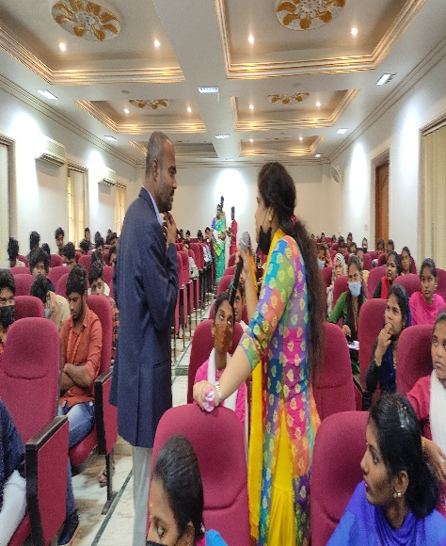  EDP Funded Program

EDC & IIC Report 2022-2023 link
EDC and IIC report.docx

Star rating certificate 2022-2023
https://jeppiaarartscollege-my.sharepoint.com/my?login_hint=jayaselvi%2Ecommerce%40jeppiaararts%2Ein&id=%2Fpersonal%2Fjayaselvi%5Fcommerce%5Fjeppiaararts%5Fin%2FDocuments%2FStar%20Rating%20Certificate%2FStar%20Rating%20Certificate%2Epdf&parent=%2Fpersonal%2Fjayaselvi%5Fcommerce%5Fjeppiaararts%5Fin%2FDocuments%2FStar%20Rating%20Certificate

Prepared by
Dr.S.Jayaselvi
IIC President Principal

